**Machine Learning : Decision Boundaries**

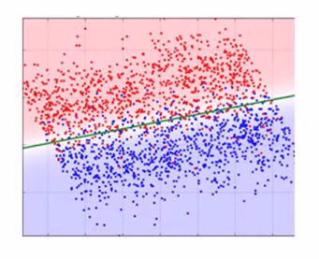

* **Red Points : Positive data points (examples)**
* **Blue Points : Negative data points (examples)**
* **Red Region : Positive region**
* **Blue Region : Negative region**
* **Green Line : Decision boundary for a particular classifier**

**KNN Decision Boundary**

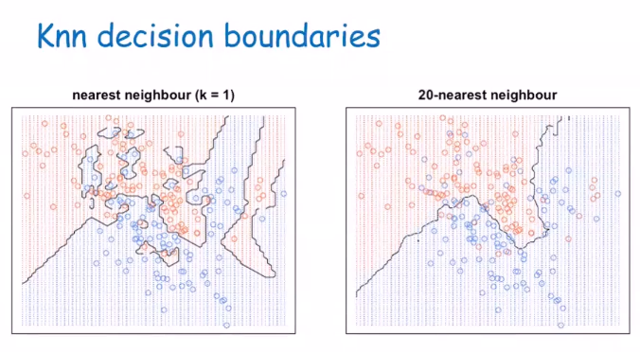

**Decision Tree Boundary**

